The Neat project has acquired an Thermal Imaging Camera (TIC) for the use within the village. The camera is the property of the Nassington Parish council so we request all users to take good care of it.
This camera has basic features and is more automated than the more sophisticated ones so as to enable users with little experience to gather meaningful data more easily.
The terms and conditions of the loan
- The HIKMICRO ECO camera is a basic TIC. Please look after the camera and return it in the same condition that you received it.
- Please don’t change any of the camera settings – only use the buttons identified in the instructions below.
- The camera will be supplied fully charged and with the current time and date set. If the charge needs to be topped up, connect the charging lead to the connection under the flap at the bottom of the handle.
- The temperatures shown in the images are relative rather than absolute, as the camera is not regularly calibrated. Damp patches can distort the temperatures measured, as they can register as cooler if the temperature is rising and warmer if the temperature is dropping.
 | User | For NEAT Project
Received in good condition (please sign)
Date / Time
Returned in good condition (please sign)
Date / Time

General introduction to using a TIC
A lot of people think that the best use of the camera is from the outside as the best use of the camera as seen on TV commercials usually for double glazing or replacement windows which demonstrates vividly heat bleeding out of the house. In fact the best use of the camera is to use it inside the property to look for cold bleeding into the house through such things as draughts or poor insulation.
It is important that there is a reasonable temperature differential between the outside and inside the greater the differential the better the results in practice a differential of at least 10deg C is needed. this is usually during the night.
The camera converts IR data into colour-coded pictures, showing the approximate surface temperature of objects in its view. Blue is cold and red is warm going to white which is very hot.
The images can be used to find weaknesses in the insulation or information about the heating system, for example:
- Cold spots where heat is being lost around a poorly sealed door, window, loft hatch or a letter box.
- Gaps in loft insulation that create cold areas on ceilings.
- Gaps in floorboards on suspended floors or cold floors over unheated areas such as over an unheated room such as a garage
- Variations in outer wall temperatures due to incomplete cavity wall insulation.
- Hot water pipes under a floor or in a wall.
- Uneven heating of radiators perhaps due to air at the top or sludge at the bottom.
Your findings will fall into 3 categories:
Category A type is one that requires minimal action such as better draught exclusion around a door or window.
Category B type is one that requires a more involved action such as fitting insulation on a garage ceiling. This would involve some expense.
Category C type is one that requires major work such as missing or inadequate insulation in areas where major work is required such as removing plasterboard or having to install insulation and plasterboard to increase thermal resistance.

General description of what the camera is good at and requirements for using it and obtaining useful information. The

The camera controls

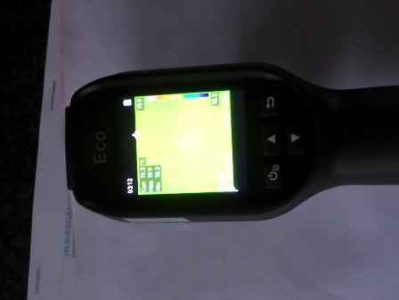
On/off switch hold for 2 seconds
Light that red when charging green when charged.
Press again to go into menus these should not need changing
Back buttom
Flap under which is USB C connector for charging and downloading pictures
Toggle up and down when in menu mode.
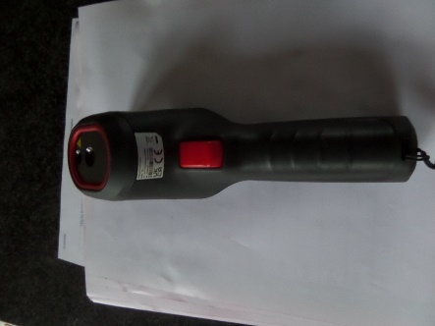
Trigger to point laser and capture image

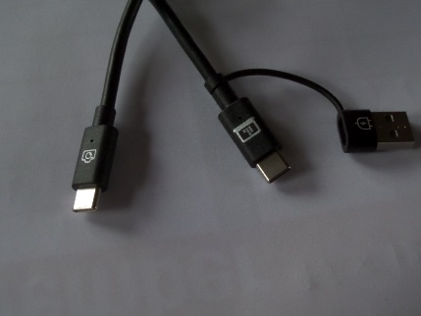
The cable for charging and download of images YOU MUST get it the right way round the ends are marked or it will not work.

How to use the camera

Charging the battery.
Use camera USB cable only as others will not work. A small red light in the ON/OFF button which goes green when fully charged.

Downloading the images.
Plug USB into laptop and pick up files as you would with a memory stick. Again the USB must be plugged in the correct way, the ends are marked with camera icon on one end

Interpreting the images
The images have a temperature palette which can be seen on the RH side of the screen. Blue is where cold is leaking in.

Capturing images.
Pull trigger and at the bottom of the screen it will say “capture succeeded”
Some example images

Precautions
Take care when using the laser pointer and never point at anyone or pets as it may damage their eyes

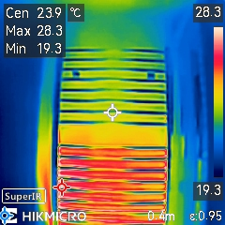
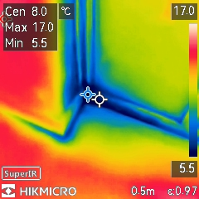

Towel rail with top half cool needs bleeding
Cold air leaking in at bottom of a door. More draught excluder needed or door adjustment
Red marker max in LH corner and blue marker is min in LH corner.
White marker is Centre in LH corner and is where you are pointing the camera, if you pull the trigger is where the laser
These markers are set automatically

To Be retained by NEAT team

Neat team loan approver | Name | Date collected
oanee | Name | Contact #

 | User | For NEAT Project
Received in good condition (please sign)
Date / Time
Returned in good condition (please sign)
Date / Time

